**Chapter 6 Exercises**

6.1 Add a TP700 Comfort Panel to the Project and configure the PLC Connection 2

6.1.1 Add a TP700 Comfort to the Project. 3

1) Add a new TP700Comfort to the project. 3

6.1.2 Define the HMI Connection between the HMI and the S7-1500 PLC. 4

1) Define the data connection between the TP700 and the S7-1500 PLC. 4

**6.1 Add an TP700 to the Project and configure the PLC Connection**

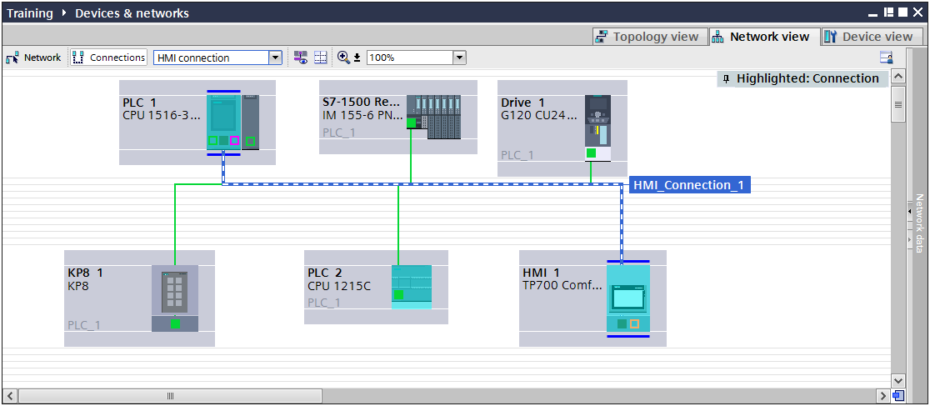

1. Add a TP700 Comfort Panel to the Project and configure the PLC Connection

**Description**

Add a TP700 Comfort Panel to the project and configure the data connection to the S7-1500.

**Objectives**

1. Add a TP700 to the Project
2. Configure the Data connection to the PLC.

**Prerequisites**

The following prerequisites must be completed before this exercise is started:

* Chapter 5 exercises have been completed, OR the Chapter 6 Seed Project Archive has been retrieved and is open for editing.

### Add a TP700 Comfort to the Project.

|  |
| --- |
| 1. Add a new TP700Comfort to the project. 2. With your project open in the Project view, double click on the “Add new device” in the Project tree. 3. In the “Add new device” dialog, select HMI, then select the device TP700 Comfort. 4. Accept the default name “HMI_1” 5. Note the panel version is version 13.0.1.0 6. Make sure the “Start device wizard” is NOT checked. 7. Click “OK”.      1. After a brief delay, the object is added and the default screen, Screen_1, is opened for editing. |

### 6.1.2 Define the HMI Connection between the HMI and the S7-1500 PLC.

|  |
| --- |
| 1. Define the data connection between the TP700 and the S7-1500 PLC. 2. Open the Devices and networks editor. 3. Select the Network view. 4. Select the Profinet port of the HMI device shown in green. 5. In the Inspector window, change the port’s Ethernet address to 192.168.0.7. 6. Back in the editor Work area, select the button labeled “Connections” at the top left of the window. 7. Using the pull down right next to the Connections button, make sure “HMI connection” is selected. 8. In the main window, drag the Profinet port ***of the HMI*** and drop it on the S7-1500’s Profinet IO port. The software will define a connection and highlight it as shown below:      1. Select the highlighted connection. In the Inspector window, change the name of the connection to read “S7-1500 Connection”      1. Save your project.   *This Completes the Chapter 6 Exercises.* |